J
BIOLOGY DEPARTMENT
NAMUNGOONA SALAF SEC. SCH
HOMEOSTASIS TEST, wed June 24th, 2020

1. In an investigation, two persons A and B drunk the same amount of glucose solution. Their blood sugar levels where determined immediately and thereafter at intervals of one hour for the next six hours. The results where as shown in the table.

Time (hours) | Blood glucose level (mg/100cm³)
Time (hours) | Person A | Person B
0 | 90 | 120
1 | 220 | 360
2 | 160 | 370
3 | 100 | 380
4 | 90 | 240
5 | 90 | 200
6 | 90 | 160

a) Draw a graph of blood sugar levels of persons A and B againtime on the same axes


b) Explain each of the following observations

i) blood sugar level increased in person A between 0 and 1 hour
..............................................................................
..............................................................................
..............................................................................
..............................................................................
ii) The blood sugar levels dropped between 1 and 4 hours
..............................................................................
..............................................................................
..............................................................................
..............................................................................
c) From the graph, what is the normal blood sugar level for human beings
..............................................................................
..............................................................................
d) One of the persons has a condition know as diabetes. Suggest which person has diabetes and give a reason for your choice (03mrks)
..............................................................................
..............................................................................
..............................................................................
..............................................................................

e) How can the high blood sugar level in in the named person be controlled. (02mrks)
..............................................................................
..............................................................................
f) What is the biological significance of maintaining a relatively constant sugar level in (03mrks)
..............................................................................
..............................................................................
.............................................................................
2. The figures below show the concentration of glucose and insulin in blood before and after a glucose drink study them carefully and answer the questions that follow

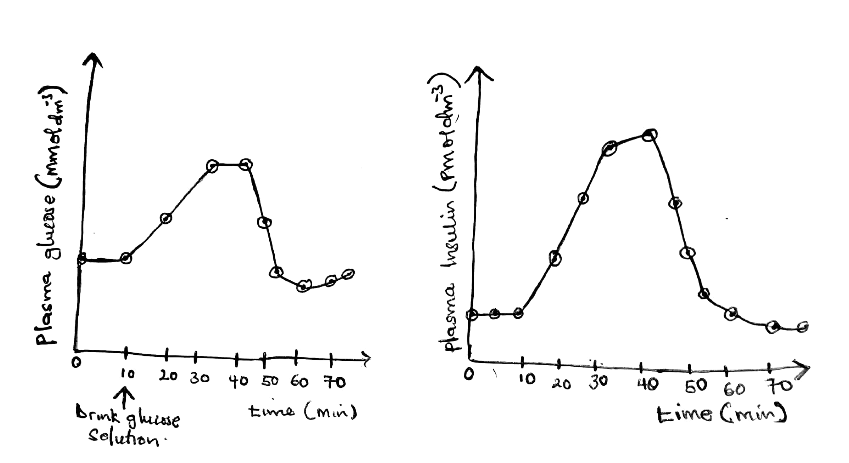

a) From the figures above explain how changes in blood glucose concentration cause
I) An increase in the concentration of insulin in plasma
..............................................................................
..............................................................................
..............................................................................
..............................................................................
ii) A subsequent fall in concentration of insin in plasma
..............................................................................
..............................................................................
..............................................................................
..............................................................................
b) Other than the concentration of glucose in blood, what other factors must be regulated in the internal environment
..............................................................................
..............................................................................
3. The illustration below shows how gland X interact with the kidney to control the amount water in blood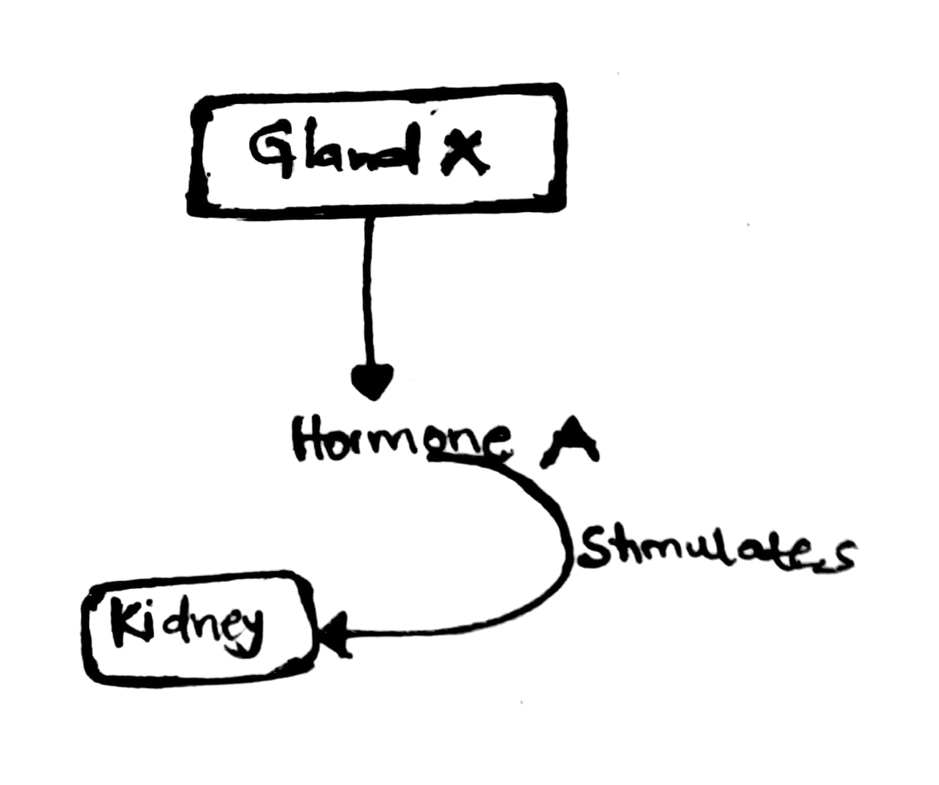
a) What term is used to describe maintaining of constant amount of water in blood (01mrk)
..............................................................................
..............................................................................
b) Identify
I) Gland x (01mrk)
..............................................................................
..............................................................................
ii) Hormone A (01mrk)
..............................................................................
..............................................................................
c) Describe the effect of hormone A onto the kidney tubules (05mrks)
..............................................................................
..............................................................................
..............................................................................
..............................................................................
d) What will happen to an individual who is unable to produce hormone X (02mrks)
..............................................................................
..............................................................................
Section c
4. a)Describe how glucose is regulated in blood (08mrks)
b) Describe the role of the kidney as an osmeregulator (07mrks)

